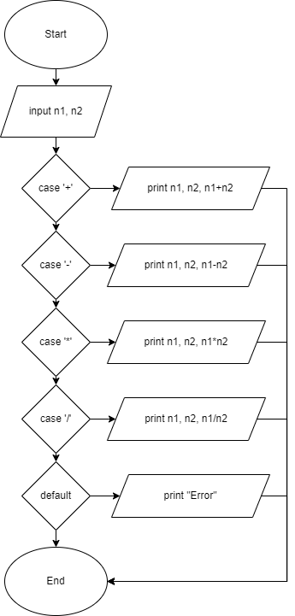In this diagram after inputting n1 and n2 you will have the option to choose which case you will use and it will display the inputted number and its equal, then after getting the output the program will end